**Preparation of electrocompetent cell (Started Week 28/3/22)**

**NOTE: This protocol should give ~40 aliquots of electrocompetent cells, each 50uL. We can halve all the volumes in this protocol to make 20 aliquots instead.**

Day 1:

1. Streak DH5 alpha cells onto LB plate w/o abx, grow overnight
2. Prepare plates and agar:
   1. 10x plain LB plates (For repreparing electrocompetent cells and positive control)
   2. 10x LB plates with kanamycin (For testing transformation protocol)
   3. 300mL LB broth with kanamycin (For culture after transformation)
   4. 300mL plain LB broth (For repreparing electrocompetent cells)

Day 2:

1. Inoculate 2ml LB culture at 37oC overnight
2. Meanwhile, prepare 350mL 10% Glycerol (28/3, prepared from 80% glycerol and aut H2O by RIF)

Day 3:

1. Dilute all (28/3 all solutions halved to only make 10 aliquots) of the overnight culture into 200mL fresh LB broth
2. Incubate at 37oC with shaking (250rpm) until OD600 0.3
   1. Measure OD600 every hr until 0.2, then prepare ice bath – place ALL bottles, solutions (glycerol, centrifuge tubes, aliquot tubes) in ice bath (30/3, took 1.5 hours for 100mL to reach OD0.2)
   2. Measure OD600every 15-20 mins until 0.35-0.4 (Expect after ~3hrs; 30/3, took ~2.5 hours total to reach OD0.38)
3. Pre-cool at 4oC for at least 20 min, pre cool centrifuge machine
4. Split into two 50mL portions and centrifuge at 4oC (30/3, 1000g 20 mins for all spin steps)
5. Wash with 50mL 10% glycerol, centrifuge, pour supernatant
6. Wash with 25mL 10% glycerol, centrifuge at 4oC, pour supernatant
7. Wash with 12.5mL 10% glycerol, centrifuge at 4oC, pour supernatant (30/3 pellet especially fragile here)
8. Resuspend the cells with 500uL volume of 10% glycerol
9. Aliquot into 50uL portions
10. Store in -80 oC (30/3 changed to 20)

Note: keep your samples on ice during washing

**Preliminary Experiment: Recombinant Plasmid Preparation – Short Insert Digestion, Fragment Selection, Purification & Ligation**

Part 1: Digestion (30/3)

1. Nanodrop to test concentration of short insert and plasmid and determine **volume needed for 5ug DNA each, prepare oven/water bath to be 80°C (30/3, plasmid and qnrA were 210 and 5ng uL-1 respectively)**
2. Add DNA, BglII, nuclease free water, Anza Buffer in the following ratio, but scale up to 100uL (i.e. multiply table’s values by 5) **USE 10X Red for short insert DNA; CONCURRENTLY, PREPARE THE SAME MIX FOR THE PLASMID VECTOR AND BAMHI, scale up to 100uL and USE 10X buffer (30/3, used buffer red for plasmid too because was uncertain if plasmid DNA was degraded)**

|  |  |
| --- | --- |
| Reaction volumes (30/3) | |
| qnrA (bglII) | Plasmid (BamHI) |
| 4.6uL DNA (27ng) | 2uL DNA (420ng) |
| 40uL Anza red | 4uL Anza red |
| 2uL enzyme | 1uL enzyme |
|  | 13uL water |

1. Incubate both at 37°C for 15 minutes,. **In the meantime, start preparing 1% agarose gel (30/3 add 0.5g powder, 50mL TAE, 1.5uL cyber red)**.
2. Heat inactivate enzymes by incubating at 80°C for 20 minutes, let plasmid mix cool to room temperature and then store in 4°C for now

Part 2: Fragment Selection (30/3)

1. Directly load short insert reaction mixture to gel (1% agarose) (30/3 use 1kb and 200bp DNA ladder, add 6x loading dye for ladders, no need for DNA, 100volts, 30 mins)
2. Excise appropriate fragment size (30/3 excised 140bp and 2200 for insert and plasmid)
3. Run Qiagen gel extraction kit (30/3 put ~400mg of gel at a time, can run nanodrop at this point for good measure)

Part 3: DNA Purification, dephosphorylation (30/3)

1. Run DNA purification kit (30/3 can run nanodrop afterwards for good measure, concentration dropped to 3 and 7ng uL-1 for plasmid and insert respectively)
2. Nanodrop to determine **concentration and volume needed for 1ug DNA, prepare oven/water bath to be 80°C**
3. Prepare the following reaction mix (mix by pipetting up and down), **use 10X Buffer because no need to run gel. Concurrently, prepare the same mix for the plasmid vector from the fridge**

1. Incubate at 37°C for 15 mins
2. Heat inactivate enzyme by incubating at 80°C for 5 minutes

Part 4: Ligation (30/3-31/3)

1. Nanodrop plasmid vector and dephosphorylated short insert to determine volume needed for 100ng and 300ng of DNA respectively
2. Prepare reaction mix in the following ratios.

|  |  |
| --- | --- |
| Reaction volumes (30/3) | |
| qnrA (bglII) | Plasmid (BamHI) |
| 4.6uL DNA (27ng) | 2uL DNA (420ng) |
| 40uL Anza red | 4uL Anza red |
| 2uL enzyme | 1uL enzyme |
|  | 13uL water |

1. Incubate at room temperature for 15 minutes
2. Store reaction mixture at 4°C for transformation next day.

Preliminary Experiment: Transformation Protocol

Part 1: Transformation

1. Ligation mixtures were drop dialyzed via 0.025 um cellulose membrane from Millipore in removal of salts to increase electroporation efficiency (30/3, should do right away since long waiting time, note washing step will dilute samples).
   1. <https://international.neb.com/protocols/2013/09/16/drop-dialysis>
2. Prechill 3 electroporation cuvettes
3. Add 1uL DNA to 50uL of electrocompetent cells. (Make 3 preps) Homogenize.
4. Transform DH5Alpha cells at 10 uF, 600Ω, and 1800 V
5. Immediately recover with either (30/3, only used SOC medium):
   1. 900uL plain LB broth (Positive control)
   2. 1mL SOC medium (Compare efficiency of recovery with LB broth)
   3. 900uL LB broth with kanamycin
6. Incubate at 37oC for 1 hour with shaking at 250 rpm.

Part 2: Culture/Screening.

1. Plate 100uL of each culture in the following plates (30/3 spread rather than streak)
   1. Plain LB plate (Positive control)
   2. LB plate with Kanamycin (Test successful transformation)
2. Grow overnight

Results from 30/3 suggest electrocompetent cell preparation and transformation protocol successful, but restriction digestion & ligation protocol unsuccessful; should improve by:

1. Better PCR purification & Gel Extraction kits (kits are 2 years old)
2. More DNA to start with for restriction digestion (Target 1ug
3. Short inserts likely unsuitable (too short, fragment ends don’t work with BamHI), should use alternative
   1. Will reattempt digestion (according to Penders multiple enzyme protocol) on *E. coli* ATCC 25922
   2. Predicted gel from just fragment of genome(generated via NEBcutter):
   3. 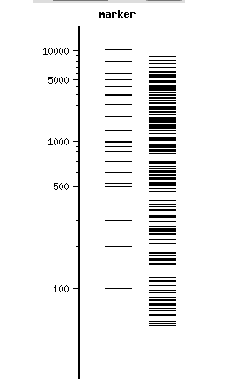

Sze, +ve insert (recombinant w/ dialysis):

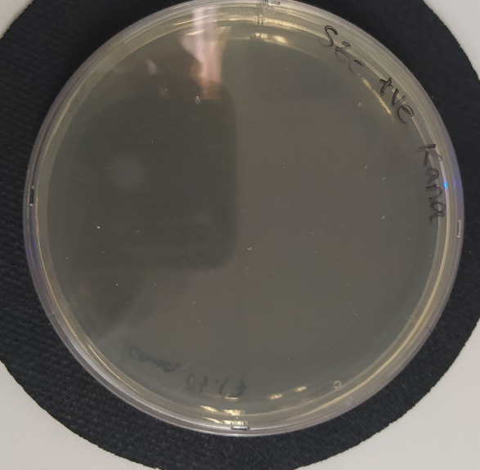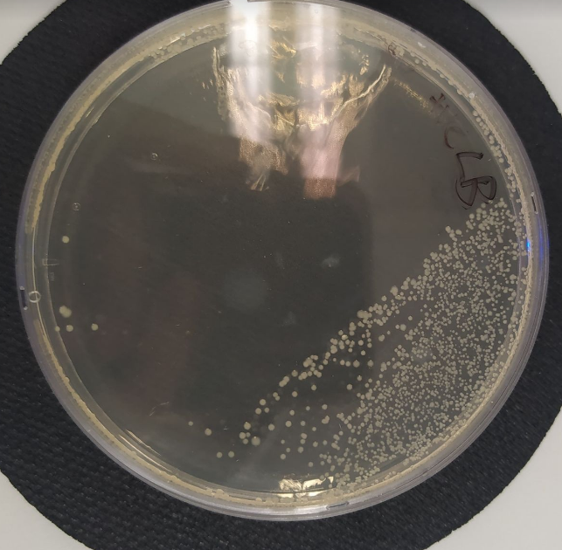

Sze, -ve insert (plasmid w/ dialysis):

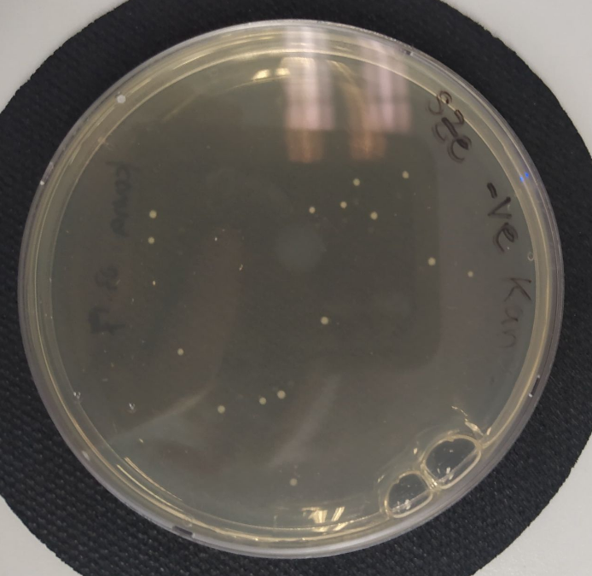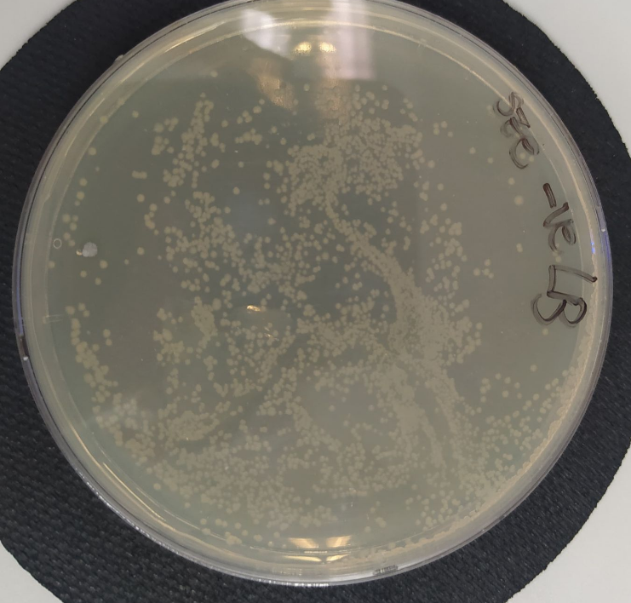

ZX, +ve insert:

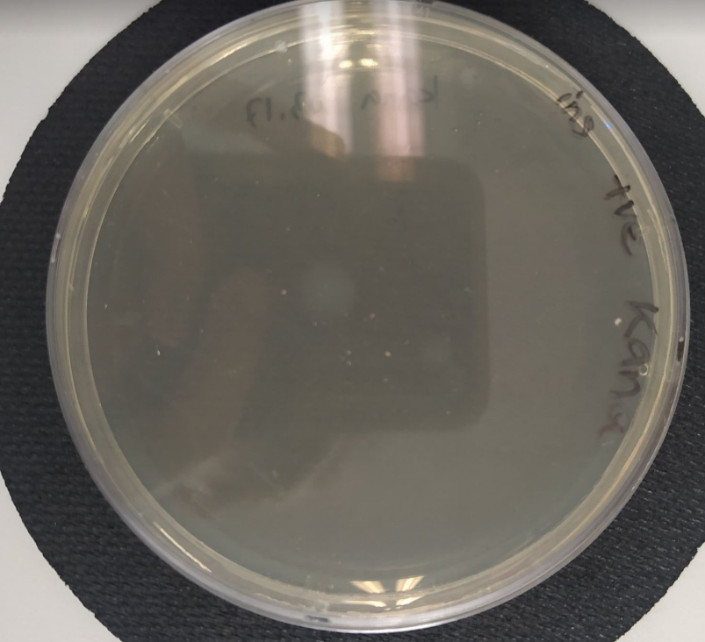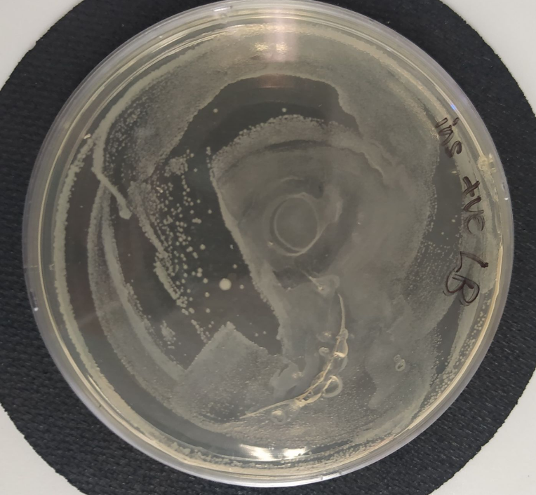

ZX, -ve insert:

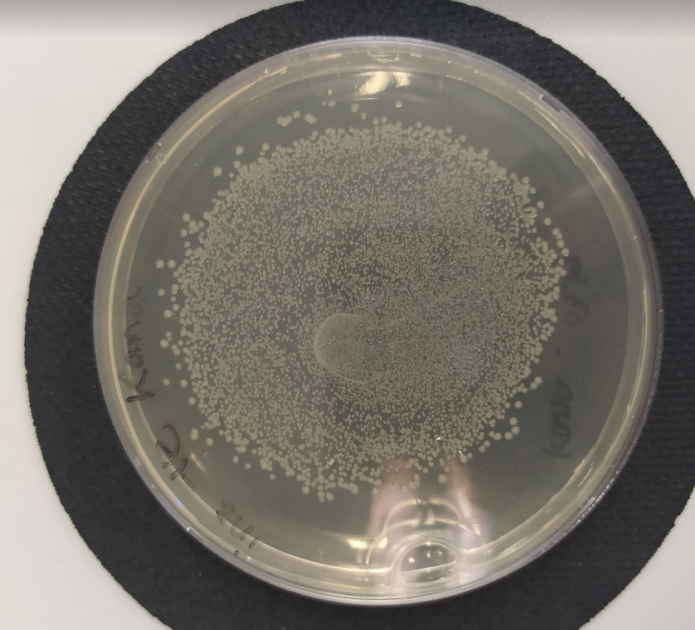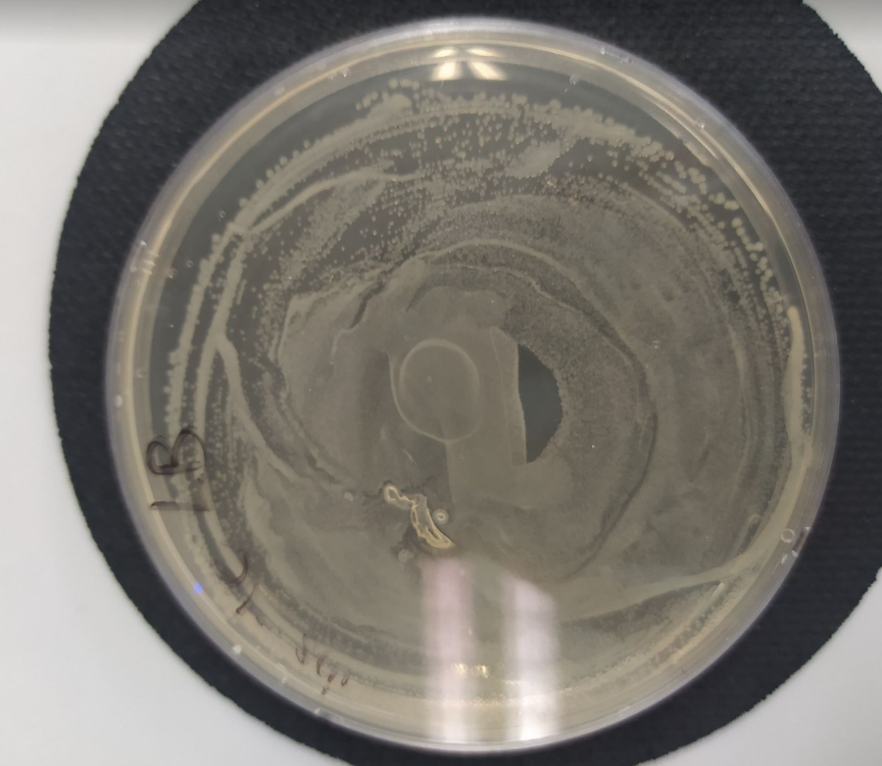

ZX, plasmid only (growth on both kana & LB):

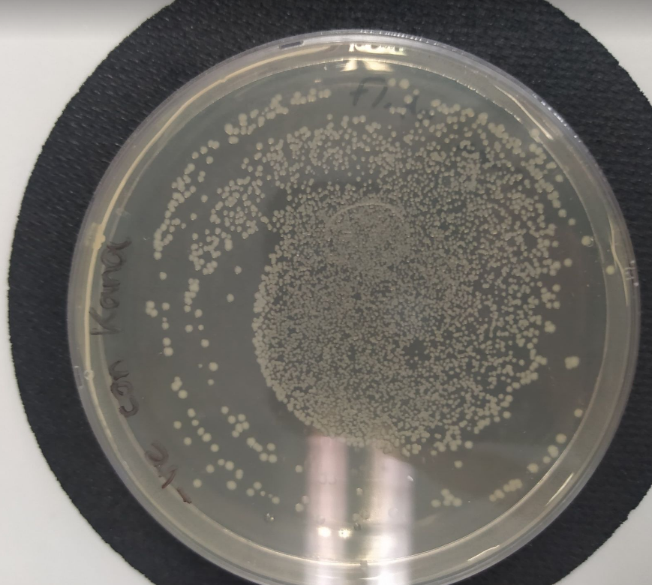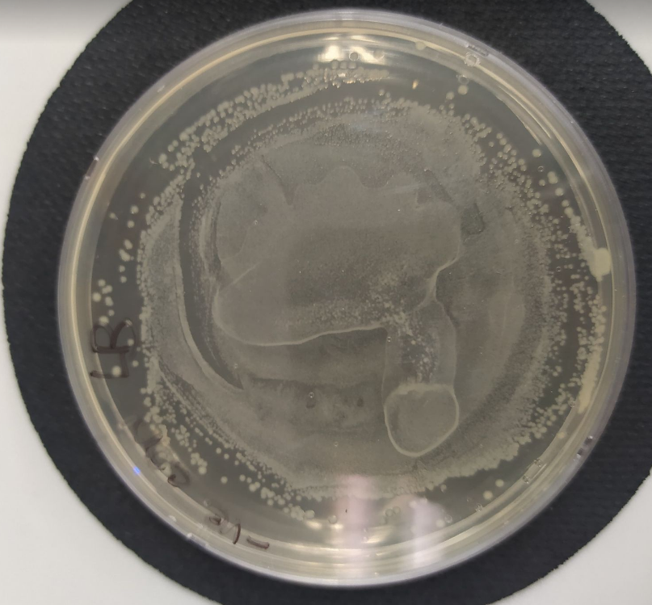

Part 3: PCR – 30/3 Did not do since ligation unsuccessful

Modifications to protocol 4/4/22:

1. Generate own stock of ATCC 25922 (verify pure culture, grow stock and streak)
2. Extract DNA and verify sample quality
3. Undergo restriction digestion with BamHI AND BglII (BstYI missing so cannot use for now)
4. Still need to test efficiency of drop dialysis

Preparation of ATCC cells and electrocompetent cells (Week 4/4/2022)

Prior Prep:

1. Prepare extra LB broth and TSB broth for use

Day 1 (6/4/2022):

1. Streak ATCC cells onto MHA to ensure pure culture
   1. Prepare tryptic soy broth if need be
2. Streak DH5 alpha cells onto LB plate w/o abx, grow overnight

Day 2 (7/4/2022):

1. Inoculate ATCC into 7mL tryptic soy broth and incubate overnight
2. Inoculate DH5 cells into 7mL LB broth and incubate overnight

Day 3: (8/4/2022)

1. Dilute all of the DH5 overnight culture into 200mL fresh LB broth
2. Incubate at 37oC with shaking (250rpm) until OD600 0.3
   1. Measure OD600 every hr until 0.2, then prepare ice bath – place ALL bottles, solutions (glycerol, centrifuge tubes, aliquot tubes) in ice bath (30/3, took 1.5 hours for 100mL to reach OD0.2)
   2. Measure OD600every 15-20 mins until 0.35-0.4 (Expect after ~3hrs; 30/3, took ~2.5 hours total to reach OD0.38)
   3. While waiting, stock ATCC cells into 80% glycerol, spin down rest to do DNA mini kit (Tissue protocol, acc to pg. 56; refer to next page for protocol)
3. Pre-cool at 4oC for at least 20 min, pre cool centrifuge machine
4. Split into two 50mL portions and centrifuge at 4oC (30/3, 1000g 20 mins for all spin steps)
5. Wash with 50mL 10% glycerol, centrifuge, pour supernatant
6. Wash with 25mL 10% glycerol, centrifuge at 4oC, pour supernatant
7. Wash with 12.5mL 10% glycerol, centrifuge at 4oC, pour supernatant (30/3 pellet especially fragile here)
8. Resuspend the cells with 500uL volume of 10% glycerol
9. Aliquot into 50uL portions
10. Store in -80 oC (30/3 changed to 20)

Note: keep your samples on ice during washing

DNA Mini Kit Protocol for extracting gDNA from ATCC culture

1. Heat 2 heating blocks, 56 and 70 degrees
2. Pipet 1 ml culture into 1.5 ml microcentrifuge tube, centrifuge for 5 min at 5000 x g (7500 rpm).
3. Calculate the volume of the pellet or concentrate and add Buffer ATL (supplied in the QIAamp DNA Mini Kit) to a total volume of 180 μl.
4. Follow the “Protocol: DNA Purification from Tissues“ from step 3 (page 33), i.e.
   1. Add 20 μl proteinase K, mix by vortexing, and incubate at 56°C until the tissue is completely lysed.
   2. Vortex occasionally during incubation to disperse the sample, or place in a shaking water bath or on a rocking platform. Note: Proteinase K must be used. QIAGEN Protease has reduced activity in the presence of Buffer ATL.
   3. Lysis is usually complete in 1–3 h. Lysis overnight is possible and does not influence preparation. To ensure efficient lysis, a shaking water bath or a rocking platform should be used. If not available, vortexing 2–3 times per hour during incubation is recommended.
5. Briefly centrifuge the 1.5 ml microcentrifuge tube to remove drops from the inside of the lid.
6. Remove RNA.
   1. First add 4 μl RNase A (100 mg/ml), mix by pulse-vortexing for 15 s, and incubate for 2 min at room temperature (15–25°C).
   2. Briefly centrifuge the 1.5 ml microcentrifuge tube to remove drops from inside the lid before adding 200 μl Buffer AL to the sample.
   3. Mix again by pulse-vortexing for 15 s, and incubate at 70°C for 10 min.
   4. Briefly centrifuge the 1.5 ml microcentrifuge tube to remove drops from inside the lid. It is essential that the sample and Buffer AL are mixed thoroughly to yield a homogeneous solution. A white precipitate may form on addition of Buffer AL. In most cases it will dissolve during incubation at 70°C. The precipitate does not interfere with the QIAamp procedure or with any subsequent application.
7. Add 200 μl ethanol (96–100%) to the sample, and mix by pulse-vortexing for 15 s. After mixing, briefly centrifuge the 1.5 ml microcentrifuge tube to remove drops from inside the lid.
   * 1. It is essential that the sample, Buffer AL, and the ethanol are mixed thoroughly to yield a homogeneous solution. A white precipitate may form on addition of ethanol. It is essential to apply all of the precipitate to the QIAamp Mini spin column. This precipitate does not interfere with the QIAamp procedure or with any subsequent application. Do not use alcohols other than ethanol since this may result in reduced yields.

3 Enzyme Restriction Digest with ATCC strain